Instructions For Blood Diamond Challenge

- Download content
- Create a new index.html with basic structure. If necessary, use your saved reference.html page for the basic page or basic code in previous type exercise.
- Create the following tags inside<body> tag: how would you organize the page?
  - <header></header>
  - <section></section>
  - <nav></nav>
  - <div id=actors></div>
Now we’ll write the embedded css code: be sure to place in the <head> between the <style> </style>

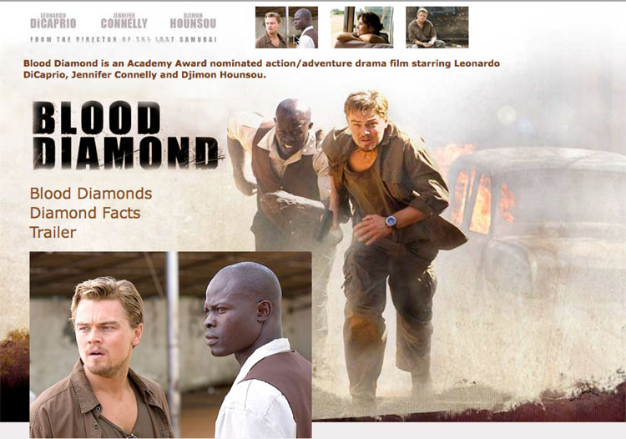

- Apply Background Image to body tag using body { background-image: url(image_name.jpg); } How would you make sure the image doesn’t repeat?

- <header> using image source tags in html code, place three sm images inside and then style <header> with left margin to move it to the right of the actor’s names. {margin-left: ???px;} What selector <tag> would you target to add spacing to the right of each small picture? Do it!
- Insert a paragraph tag below the “header” and paste the text provided in it. Style the text with a new class that has your choice of type, size and color. Do you remember that a class in css always begins with a . and is applied by putting it in the html code. <p class=browntext> for example.
- Insert blood logo image between text and navigation
- <nav> Place three text links (vertically) for each navigation term; Blood Diamonds, Diamond Facts,and Movie Trailer. Link to URLs below. Set desired linking styles with the a:link, a:visited and a:hover. You could also use an unordered list <ul> with three list items <li></li> to create a vertical list. We’ll demo this in class. Do it either way.

Note: (LoVe Hate)When setting the style for several link states, there are some order rules: a:hover MUST come after a:link and a:visited
a:active MUST come after a:hover

- Today we introduced the div tag. We’ll use it and add an id to more specifically name and target it. Add <div id=actors></div> below your navigation. Place one of the large images inside this div tag. You pick the image. If you want to adjust spacing down or right just apply the margin-top or margin-left property to this or any other <div> by using the div id selector #actor
- Clean-up any CSS or code and troubleshoot as needed.
- Test and resolve any problems…..Wow!

Text (put inside new <p> </p>under small top row of images)
Blood Diamond is an Academy Award nominated action/adventure drama film co-produced and directed by Edward Zwick and starring Leonardo DiCaprio, Jennifer Connelly and Djimon Hounsou.

Links for Navigation

Blood Diamonds
http://en.wikipedia.org/wiki/Conflict_diamond

Diamond Facts
http://www.diamondfacts.org/

Movie Trailer
http://www.apple.com/trailers/wb/blooddiamond/medium.html

Designer Challenges! Read and Do!!

#1 Add a @font-face type to replace the Blood Diamond logo image. Start by selecting a similar font from dafont.com and download. Then use fontsquirrel.com to create a @font-face kit. The kit will create a variety of fonts and give you the css code to insert. Learn by doing and reading..in our book.

#2 Create a Rollover Image In the <div id=actors>

Your original page works, now consider the added impact if the large actor image changed when you rolled over. We can do this with css by using the a:hover property to swap images. We’ll be using variations on this technique to create navigation buttons that change on rollover to give user “feedback”. There are many different css rollover techniques this is just a simple one that works!

- First replace the image in the actor div with a transparent gif image in an anchor tag. All images you use in a rollover need to be exactly the same size. I’ve provided an image for this called target.gif. The tag you need to apply is written below.
- <a id=rollover><img src=images/target.gif alt=rollover image border=0></a>
- This link tag holds a place for the rollover images that will be applied in the css code.
- Here are the two css rules that make the rollover work:
- a#rollover img {
background:url(images/djimon_hounsou.jpg);
}
a#rollover:hover img {
background:url(images/jennifer_connelly.jpg);
}

Wow! Do you understand how and why this code works? Be sure to save this information so you can use in future work? Link this exercise to your exercise page.

